Autonomous kite network systems

Assumptions on Proposals

### Proposals

The following models describe 4 Kite Turbine system configurations. The systems require increasing levels of development and autonomy for safe operation.

We describe 5 levels of autonomy (end of this document) which Kite Turbines and Lifting Kite Networks will employ. The simplest, level 1, mechanical autonomy with human interaction, has been well tested.

### Background

Windswept and Interesting developed a series of mechanically autonomous kite turbines. University of Strathclyde analysed the performance of 9 rotor configurations, over 120 hours of flight & 45 test flights. Over the test period the efficiency and power output of our turbines increased 10X. (Power harvesting factor ζ is now around 3.) Our Kite Turbines have the safest configuration & the best AWES Power/Weight & Power/Wing Area. This is the only AWES with continuous rotary output.

A lightweight tensile design, exploiting network deployment, makes Kite Turbines very scalable.

Kite Turbine power coefficients have stayed constant with stacking. We predict the following performance benefits with network scaling … decreased drag, maximised utility of harvested airspace, robust operation, mass production with unitised wing components, modular reconfiguration while flying & in deployment, networked form safety and more.

This is the first predictive LCOE analysis by W&I on our systems at scales over 10kW. W&I have no prior experience of manufacturing Kite Turbine products at this scale. There will be a lot of scope for production efficiency as compared to the costings shared here.

### Scale choices

The 4 systems presented are

### **Model Proposal 1** 10kW Kite Turbine with single lifter Level 3 Autonomy

### **Model Proposal 2** 50kW Kite Turbine with single lifter Level 4 Autonomy

### **Model Proposal 3** 1.8MW 18 lift kite network x 100kW kite turbines Level 4 Autonomy

### **Model Proposal 4** 10MW Single Kite Turbine Network no lifter Level 5 Autonomy

Models 1 & 2 represent the lower end scale of viable turbine size for their autonomy level. Larger, more profitable systems at the same level of autonomy would be possible and likely desirable.

### **Model Proposal 1**

## 10kW Kite Turbine with single lifter Level 3 Autonomy

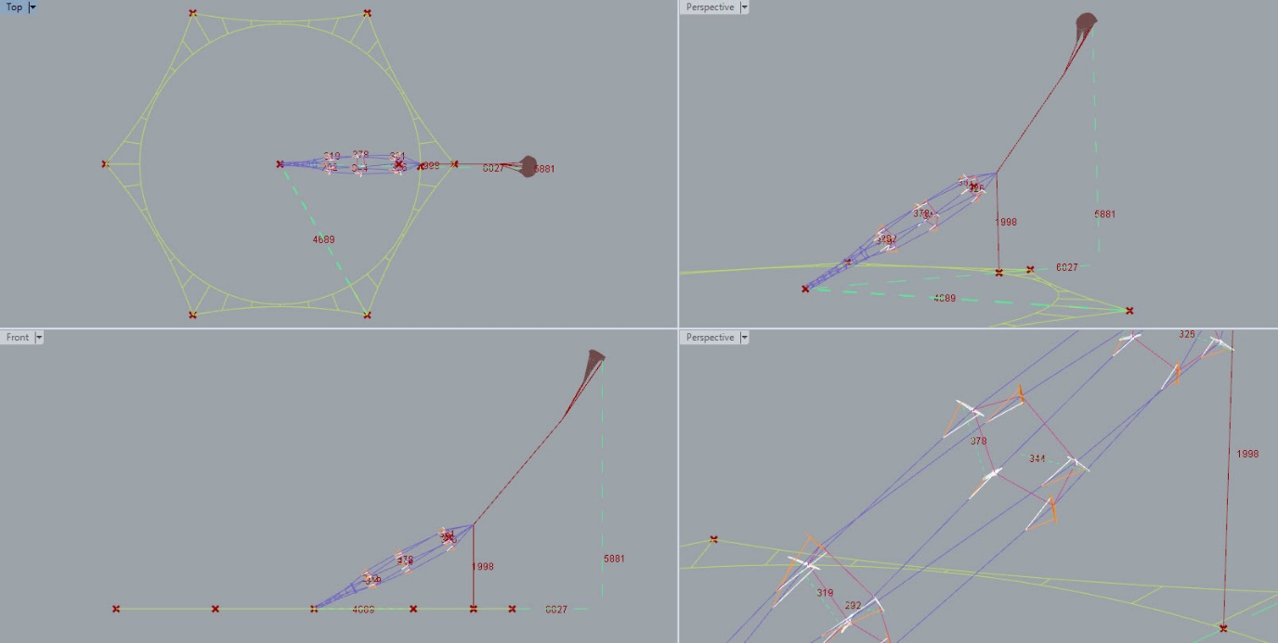

Turbine format

Turbine Rotor Layers 3

Blades per layer 5

Blade Construction 2 Carbon Spar coated foam

Rated wind speed 10m/s

Power coefficient 0.27

Tip Speed Ratio 6.5

Rotor radius 3.2m

Blade length 1.3m

Rotor speed 196 rpm

Stack elevation angle 28 deg

Supporting hoops 1 for top lift, 2 below for TRPT transition

Thrust bearing top spreader hub for lift line 2 x 25mm min

In blade lighting only for display-oriented systems

Blade control and automation requirements none at Level 3 autonomy

Moulded fuselage without controls or communications, but with payload ports available for monitoring, power gen or alternate benefits.

Lightning protection via landing if a significant risk is forecast

TRPT format

Hexagonal form with moulded knuckles and 8mmx10mm bar

Hex Diameter .8m

Torque 487 Nm

Running setpoint Tension/Torque 6

Sections 6 - 10 minimum with .59m spacing

Lines 5 x 600kg breaking 2mm dyneema

Radial centre lines to loose fit hoop guide for lift line on every ~3rd

Line fairing none yet

Lift kite format

Static KAP foil equivalent area 30m2

Altitude <60m for easy compliance

Bridle point control and comms unit with onboard power gen @~100W

Lighting aimed at skin & horizon

Required Lift line tension 1820N

Lift line length 45m Max with hoist line pulley and backline/liftline method

Ground Station Format

Main anchor geology dependant, to resist >9000N vertical

Lateral support plate 40cm dia with 6 x 30cm deep anchors, hub interface and cable routing

Single stub axle truck hub for azimuth bearing with through axle power cable access

Crane frame box section main body format with azimuth drive

Tilting head set with elevation adjusting linear actuator from frame and headset tension measurement at head tilt bearing mounts.

Small hoisting tension winch aligned behind head to hollow stub axle

Gearbox attached to head set over hollow section stub axle with rearward inline 10kW generator

PTO wheel .8m Diameter rim with ~20cm hub axial length

Thrust bearing at kite end of stub axle set with locking nuts and cotter pin.

360 Backline Format

Short driven turret carriage with dual winch on tensioned rope ring

Backline winch 1 for hoisting turbine toward lift line pulley

Backline winch 2 for lift kite launcher and recovery into short line choke turret

Backline tensioned rope ring frame anchors x 6 @ 47m radius >8000N vertical

General

Total airborne mass <6kg

Total ground-station mass <25kg

Serviceable Lifetime Ground Station 10 years

Retail Cost of 10kW Ground Station and turbine set £15.5k

Service Lifetime of Rotor Set 1.5 Years

Cost of replacement Rotor Set £1250

O&M cost £1100/year

 

### **Model Proposal 2**

## 50kW Kite Turbine with single lifter Level 4 Autonomy

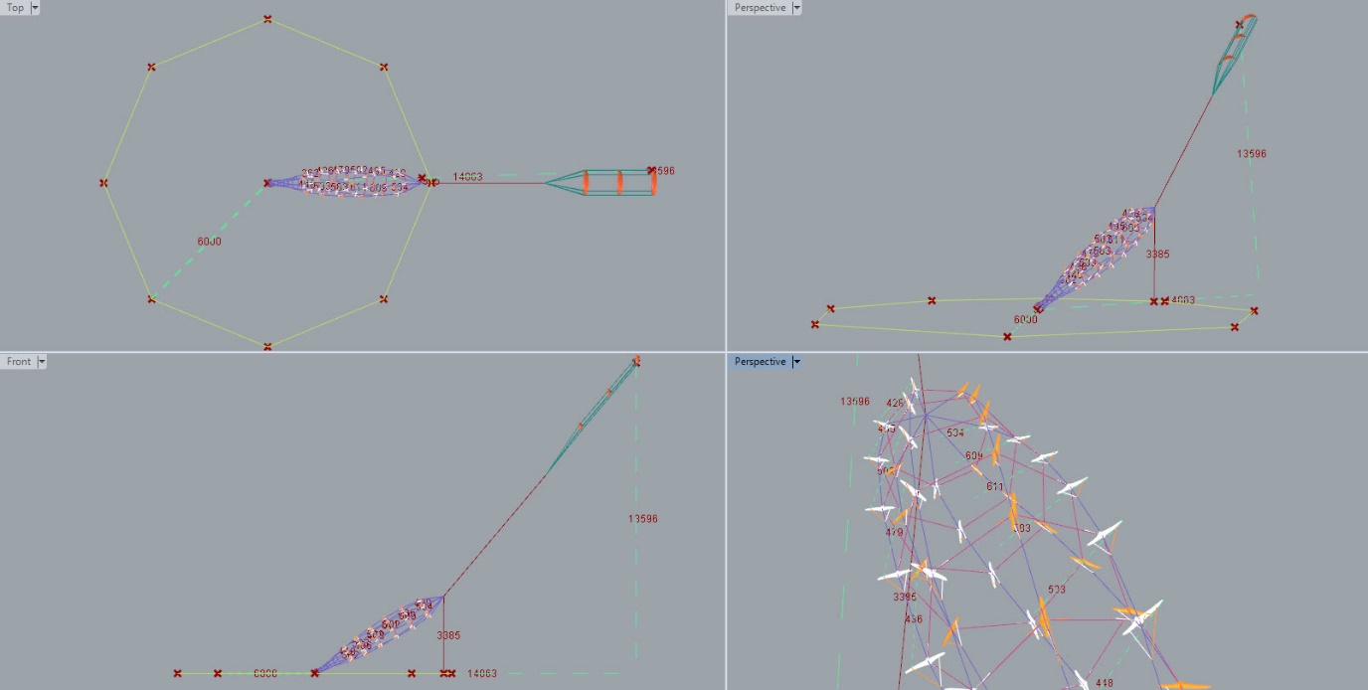

Turbine format

Turbine Rotor Layers 6

Blades per layer 7

Monocoque with ground fed power or ducted turbine onboard power

Rated wind speed 10m/s

Power coefficient 0.28

Tip Speed Ratio 6.6

Rotor radius 5.5m

Blade length 1.7m

Rotor speed 114 rpm

Stack elevation angle 30 deg

Supporting hoops 1 for top lift, 2 below for TRPT transition

Thrust bearing top spreader hub for lift line 2 x ~35mm

Blade to blade expansion twin winching control and bank adjust automation requirements

Meshed communications on each blade

Blade illumination

Lightning protection via landing if a significant risk is forecast

TRPT format

Single septagonal form, bonded ~18mm carbon tube

Septagon Diameter 1.8m

Torque 4172 Nm

Running setpoint Tension/Torque 5

Sections 6 minimum with 1.2m spacing

Lines 7 x 4000kg breaking 6mm dyneema

Radial centre lines to loose fit hoop guide for lift line on every ~3rd

Line fairing

Lift kite format

Stacked LEI to equivalent single area 250m2

Altitude ~135m

Primary bridle point control and comms unit with onboard power gen @~500W

Lighting aimed at skin & horizon

Required lift line tension <15kN depending on turbine autonomous lift steering balance

Backline control for stalled turbine and lift fail recovery

Ground Station Format

Main anchor geology dependant, to resist >60000N vertical

Lateral support plate 50cm dia with 6 x 50cm deep anchors, hub interface and cable routing

Single stub axle truck hub for azimuth bearing with through axle power cable access

Crane frame box section main body format with azimuth drive

Tilting head set with elevation adjusting linear actuator from frame and headset tension measurement at head tilt bearing mounts

Hoisting tension winch aligned behind head to hollow stub axle

Gearbox attached to head set over hollow section stub axle with rearward inline 50kW generator

PTO wheel 1.8m Diameter rim with ~35cm hub axial length

Thrust bearing at kite end of stub axle set with locking nuts and cotter pin.

8 Point Backline Format

Three LEI Stack release turrets working radially from 8 anchor 60m radius octagonal line.

Backline winch 1 for hoisting turbine toward lift line pulley

Backline winch 2 for lift kite launcher and recovery into short line choke turret with arm assist turrets further out radially.

Backline tensioned rope ring frame anchors x 8 @ 64m radius >40kN vertical

General

Total airborne mass ~25kg

Total ground-station mass ~100kg

Retail Cost of 50kW Ground Station and turbine set £51.3k

Service Lifetime of Rotor Set 2 Years - Ground Station 12 years

Retail Cost of replacement Rotor Set £11950

O&M cost £2400/year



### **Model Proposal 3**

## 1.8MW 18 lift kite network x 100kW kite turbines Level 4 Autonomy

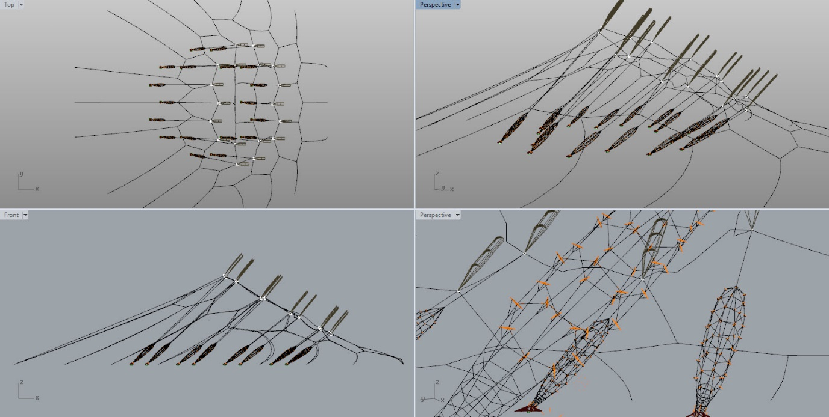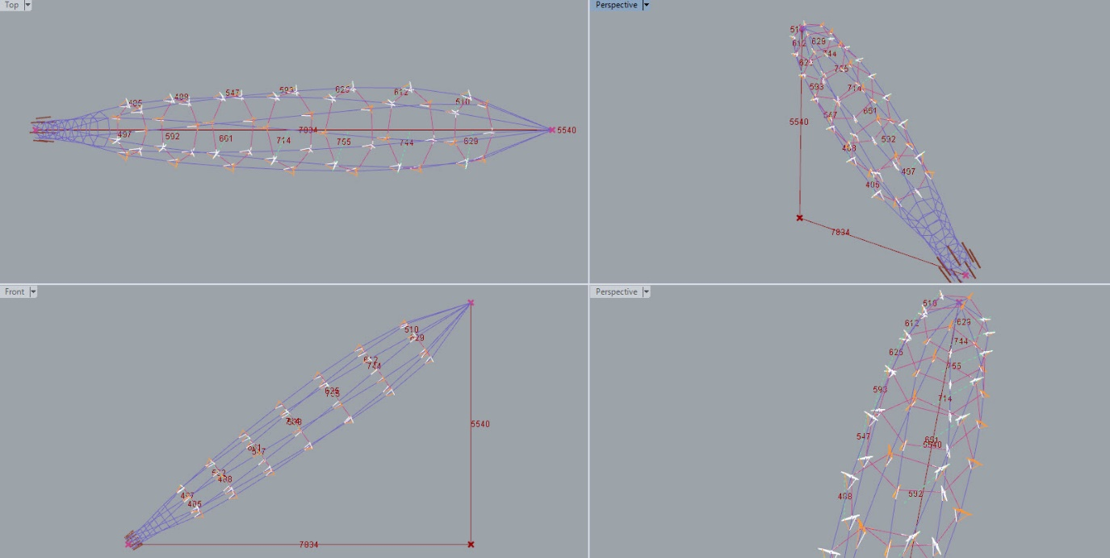

18x Turbine format

18 Top netted lifters each with a 100kW Turbine

Turbine Rotor Layers 7

Blades per layer 7

Blade Construction Carbon Monocoque with ducted turbines on top layer

Rated wind speed 11m/s

Power coefficient 0.28

Tip Speed Ratio 6.6

Rotor radius 6.6m

Blade length 1.7m

Rotor speed 104 rpm

Stack elevation angle 35 deg

Supporting hoops 1 for top lift, 2 below for TRPT transition

Thrust bearing top spreader hub for lift line 2 x ~45mm

Blade to blade expansion twin winching control and bank adjust automation requirements

Meshed communications on each blade

Illumination over top via networked wiring

Lightning protection via outer net lines and landing if a significant risk is forecast

18x TRPT format

Single septagonal form, bonded ~30mm dia carbon tube

Septagon Diameter ~3m

Torque 9140 Nm

Running setpoint Tension/Torque 5

Sections 6 minimum with ~1.8m spacing

Lines 7 x 9000kg breaking 12mm dyneema

Radial centre lines to loose fit hoop guide for lift line on every ~3rd

Line fairing

18x Lift kite format

Stacked LEI to equivalent single area ~400m2

Altitude ~135m back - ~250m front

Primary bridle point control and comms unit with network power

Lighting aimed at skin & horizon

Required lift line tension <32kN depending on turbine autonomous lift steering balance

Whole net control for stalling turbines and lift fail recovery

18x Ground Station Format

Main anchor geology dependant, to resist >130000N vertical

Lateral support plate ~60cm dia with 6 radial anchors, hub interface and cable routing

Single stub axle truck hub for azimuth bearing with through axle power cable access

Crane frame box section main body format with azimuth drive

Tilting head set with elevation adjusting linear actuator from frame and headset tension measurement at head tilt bearing mounts

Hoisting tension winch aligned behind head to hollow stub axle

Gearbox attached to head set over hollow section stub axle with rearward inline 100kW generator

PTO wheel ~3m Diameter rim with ~45cm hub axial length

Thrust bearing at kite end of stub axle set with locking nuts and cotter pin.

Extra kite handling, stability, meteorology, safety, containment, ground layout, ++ undisclosed as yet

General

Total airborne mass ~40kgx18

Retail Cost of 18x100kW Ground Station and turbine set £1.19M

Service Lifetime of Rotor Set 2 Years - Ground Station 12 years

Retail Cost of replacement Rotor Set £593695

O&M cost £28000/year

### 

### **Model Proposal 4**

## 10MW Single Kite Turbine Network no lifter Level 5 Autonomy

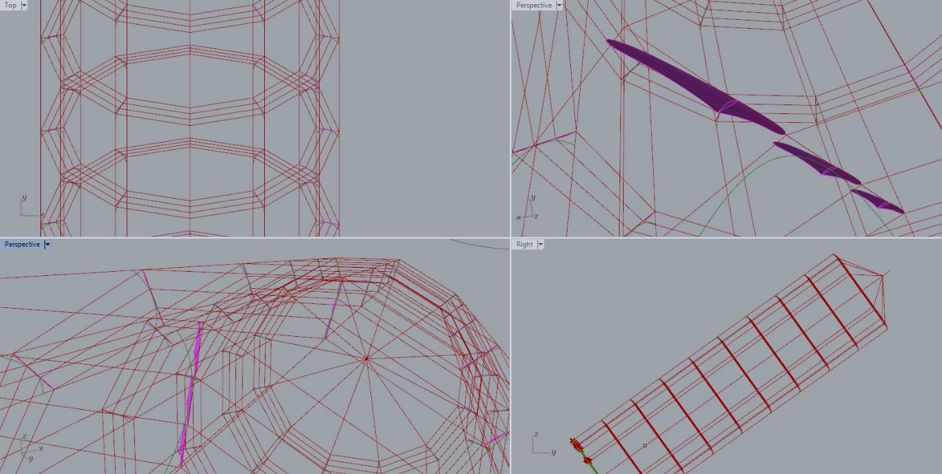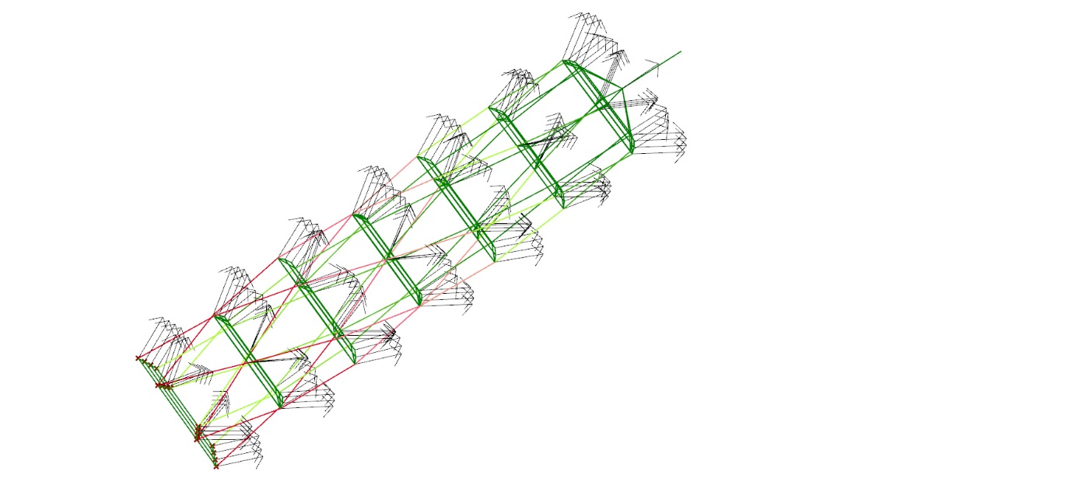

Figures for this model must be considered as more provisional than for the previous models



Turbine format

12 blade rings with 3 rings concentrically per layer over 10 layers

Carbon mould monocoque wing and fuselage with hatch for control and winching service

Top layer with ducted turbine

Rated wind speed 11m/s

Power coefficient 0.3

Tip Speed Ratio 6.9

Rotor radius 50m

Blade length 4.9(x3)m

Rotor speed 14 rpm

Stack elevation angle 35 deg

No TRPT - Turbine direct to PTO

Thrust bearing top spreader hub for lift line 2 x 45mm min

Blade to blade expansion twin winching control and bank adjust automation requirements

Meshed communications on each blade

Illumination over top layer via Top Layer RAT

Lightning protection via landing if a significant risk is forecast & sacrificial centre line

Drone interface and servicing to pilot kit

Pilot kite format

Stacked LEI to equivalent single area ~200m2

Altitude ~150m - ~200m

Primary bridle point control pod with onboard ram

Lighting aimed at skin & horizon

Required lift line tension - none

Ground Station Format

Large groundworks with truncated hemisphere range of frame support using rail to rail and active tensile anchor ring system.

12 arm servicing for modular connection and store handling of blade sets

Centre line winch

Optimal gear and generation configuration still under investigation

PTO wheel ~40+m Diameter rim

Extra kite handling, stability, meteorology, safety, containment, ground layout, ++ undisclosed as yet

General

Total airborne mass ~350kg

Retail Cost of 10MW Ground Station and turbine set ~£8.9M

Service Lifetime of Rotor Set 4 Years - Ground Station 16 years

Retail Cost of replacement Rotor Set £337k

O&M cost £50k/year



Kite Turbine Networks autonomy class definitions

(All classes include generation control enhancements based on ground station configuration & monitoring.)

**Level 1 Mechanical Autonomy suitable for <1kW to 5kW range - Already developed**

Azimuth alignment of turbine via Standard KAP style lift kite without needing control pod.

Lifted Autogyro turbine power smoothing and overspeed protections potential from twist tip leach gust spilling or spanwise compression. Reflex foil smoothing may also be applicable.

Turbine elevation height set via backline anchor. Backline anchor can either be set to run on a tensile ring rope & trolley anchoring set or just planted or set on a horsetrack range.

Manual launching and landing procedures.

Further improvements on basic mechanical autonomy performance are being developed.

Further improvements on autonomous generation and ground station performance are being developed.

**Level 2 Mechanical Autonomy + semi automation of single line lift. Turbine in 5kW to 10kW range - partly developed at W&I requiring <6 months to complete. Single prototype development budget ~£45k. 2x external AWES developers consulting sought.**

Azimuth alignment of turbine via KAP style lift kite using bridle point control pod, onboard power from 50W. Control pod communicates intention and state over standard comms networks.

Launch to be semi-autonomous. Kite is filled and held by winch at ground with control turned on before launch. Still using winching by hand to set lift line and backline height. Turbine elevation height set via backline anchor. Backline anchor can either be set to run on a tensile ring rope & trolley anchoring set or just planted or set on a horsetrack range.

Lifter can decide to force a landing to side depending on states.

Lifted Autogyro turbine power smoothing and overspeed protections potential from twist tip leach gust spilling, or spanwise compression.

Further Lift Kite Network smoothing, pattern following and robustness investigations can be performed at this level of lift autonomy.

**Level 3 = Level 2+ automation of single lift kite operation + automation of turbine by hoist deployment 10kW to 50kW range - New ground-station & back line turret construction and testing required <1 year of development from a team of 3 full time engineers. Single prototype development budget ~£155k Cooperation with existing AWES kite system developers would help.**

Azimuth alignment of turbine via larger rigidised style lift kite >45m2 using bridle point control pod, onboard power ~200W. Control pod communicates intention and state with a linked phone.

Lifter launch, flight and recovery to be autonomous. Initialisation and coupling to be manual. Kite is filled and active when held winched into the backline turret. Launch command is checked manually. Array of cameras available to assist with remote launch decision.

Two winches, one for lift kite line and backline height, the other for hoisting and lowering the kite turbine. Backline anchor turret carriage mounted to run on a tensile ring rope. System can recover turbine to ground and lifter to turret. Turbine is laid on ground via the winching recovery and held down by the lift line. Full detail undisclosed awaiting patenting.

Lifted Autogyro turbine power smoothing and overspeed protections potential from twist tip leach gust spilling, bank stall, or spanwise compression. Potential to add active flap tuning with power either from network or from turbine head gen set or from small RAT on wing.

Lift Kite Networks will be able to dynamically alter group pattern for optimal top net tension and inflation.

**Level 4 = Level 3 + PTO aligned, retracting frame supports for ground hold, launch release and recovery of rotors and TRPT.  Rotor expansion blade to blade winching. >50kW range. >1 year development from a team of 5 full time engineers. Single prototype development budget ~£400k Cooperation with existing AWES teams and OEM’s very desirable.**

Relatively less lifter requirement with lift component control on blades.

Live rescaling rotor diameter.

State analysis allows turbine prelaunch condition to be approved autonomously.

Full detail undisclosed awaiting patenting.

**Level 5 = Level 4 + PTO aligned frame automatically reconfigures and reattaches TRPT + rotors as needed. Individual blades to have NLMPC onboard flight controls, swarm network. Higher accuracy infield positioning and meteorology. 100kW + range. Development time 2+ years for a team of 10 full time engineers. Single prototype development budget £2+M. Cooperations with existing AWES kite system teams & supply chain.**

Lift kite network only for field alignment and spacing. Lift comes from rotor with ground powered launch and land.

Full detail undisclosed awaiting patenting.

All systems have potential to incorporate autonomous video / light display modes in rotor blades.